Katrina Wilhelm
November 24, 2025
CMSC 430 7382
Project 3 Documentation

Project Approach
I prepared for this project by watching the week 6 videos, reading the supplied texts and reviewing the PowerPoint slides that were provided in week 6. My next steps were to download the skeleton code and I built it and ran it with tests 1-4.txt to understand how semantic actions are used to preform the evaluation needed to interpret the program in the class’s language. Next, I incorporated new features found in the skeleton into my project 2 code. Then I used Ubuntu to confirm the project builds correctly and I confirmed that tests 1-4.txt produced the correct output.
Once I confirmed that the skeleton code built correctly and ran my initial tests, I began modifying scanner.l to evaluate real literals and hexadecimal integer literals by using a predefined C++ function atof to convert strings to doubles. I also created a custom function to handle converting strings to doubles. After making these changes, I rebuilt the program and ran test5.txt and confirmed the correct output. My next step was to modify scanner.l to evaluate character literals, including ordinary character literals and escape characters by creating another custom function. I validated the functionality by using test6.txt. Next, I added the necessary semantic actions for each of the new arithmetic operators. Once I verified each new operator functioned correctly by creating separate test cases, I ran test7.txt to confirm precedence. Next, I implemented relational and logical operators. Similar to the arithmetic operators, I ran separate tests to confirm each relational and logical operator functioned correctly. I then used test8.txt to confirm behavior when the operators are used together. Next step was to implement the if and elsif statement by implementing a similar approach to the when statement. I used test9.txt to test the functionality. I also made sure to edit test9.txt to ensure each case is tested. Next, I tested for multiple variable declarations, using test10.txt, and made sure they worked correctly. Next, I added support for parameters by modifying parser.y to handle command line arguments. I also added a global array to store converted parameter values using atof. I tested the functionality with test11.txt and test12.txt. Finally, I implemented fold statements by creating a new function in values.cc to evaluate fold statements. I then used test13.txt and test14.txt to confirm functionality of left and right fold statements. Lastly, I used test15.txt to confirm the code ran as expected.
Test Plan
Test Case 1:
The first test case is designed to confirm the compiler can correctly evaluate real and character literals.
Expected Result:
The compiler should correctly evaluate real and character literals. The program should display the correct result, which is 213.66.
Screenshot:
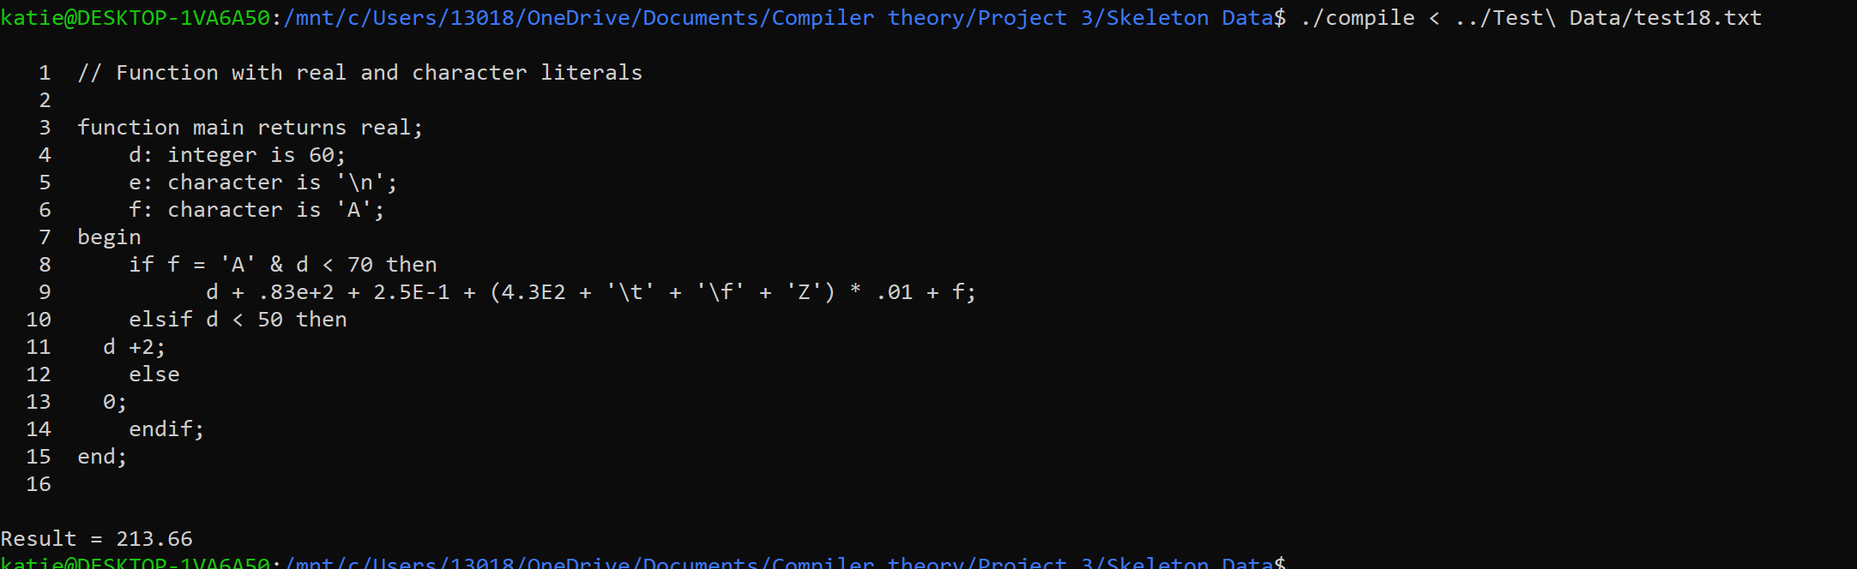
Figure 1: Test Case 1
Test Case 2:
The second test case is designed to confirm the compiler can correctly evaluate hexadecimal literals.
Expected Result:
It is expected the program will correctly evaluate hexadecimal literals and display the correct result, which is 1324.
Screenshot:
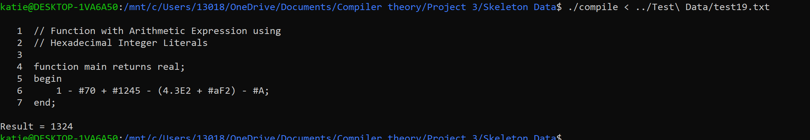
Figure 2: Test Case 2

Test Case 3:
The third test case is designed to verify all arithmetic operators work as expected and follow correct precedence rules. This test case was borrowed from the provided test cases, labeled test7.txt.
Expected Result:
It is expected the program will successfully evaluate all arithmetic operators and follow precedence rules. The program should display result = 5.
Screenshot:
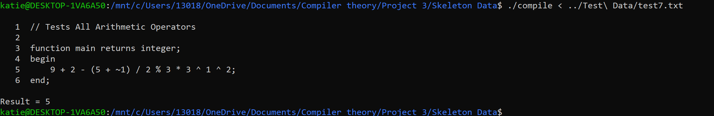
Figure 3: Test Case 3

Test Case 4:
This test case determines if the compiler can successfully evaluate relational and logical operators, while applying precedence rules. This test case was borrowed from the provided test cases, labeled as test8.txt
Expected Result:
It is expected the program will successfully evaluate all relational and logical operators and follow precedence rules. The program should display result = 0.
Screenshot:
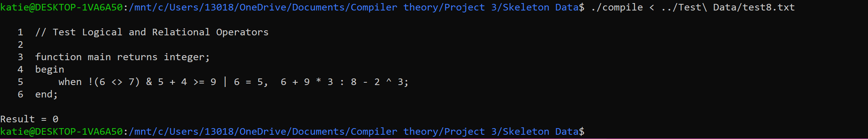
Figure 4: Test Case 4

Test Case 5:
This test case determines if the compiler can successfully evaluate all statements in the language. This test case was borrowed from the provided test cases, labeled as test15.txt. The parameters used are 1 2.5 65.
Expected Result:
The compiler should successfully evaluate all statements and operators, displaying “result = 1” at the end of the test.

Screenshot
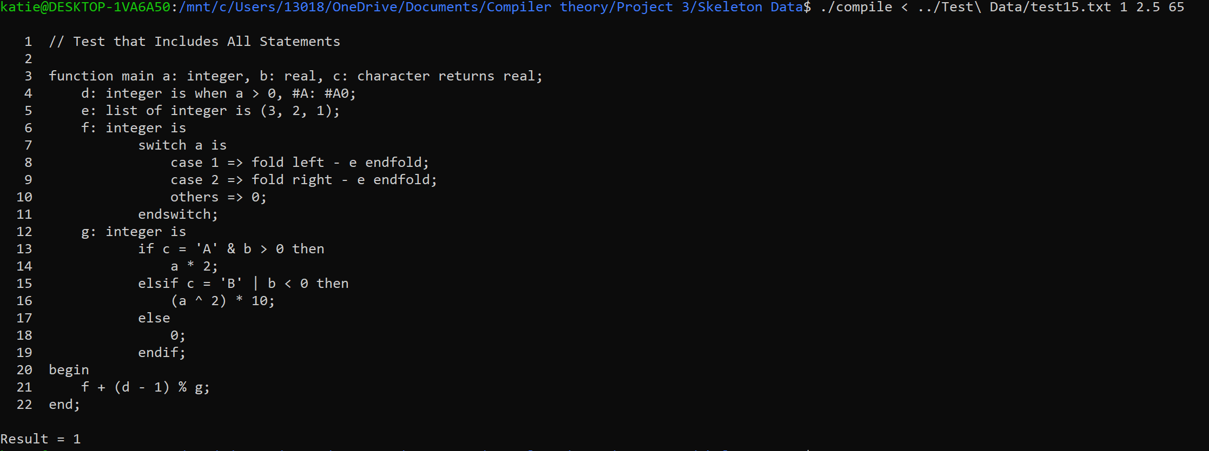
Figure 5: Test Case 5

Test Case 6:
This test case verifies that the compiler correctly handles parameters and variable declarations, including initialization using expressions. The parameters used are 1 2.
Expected Result:
The complier should correctly handle the parameters and variable declarations properly and display “result = 66“
Screenshot:
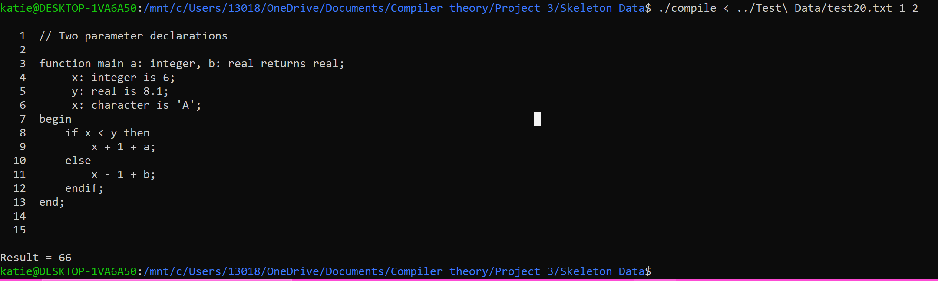
Figure 6: Test Case 6

Lessons Learned
Throughout this project, I gained a deeper understanding of how a compiler evolves as new language features are added. Incorporating the new features into my Project 2 code taught me how small changes can affect the entire system, especially when those changes are a part of the scanner and parser. Also, by adding each feature incrementally, I gained a better understanding of how grammar structure, semantic actions and token handling interact together. In addition, by adding semantic actions for all the operators, I learned how operator precedence must be included into the grammar and how a misplaced rule can change the way expressions are interpreted. I also learned how essential testing is after each modification, to ensure that each new feature works correctly and does not introduce unexpected conflicts. Overall, this project was a huge learning experience and taught me a lot about semantic translation and evaluation.
Improvements
To improve this project, I would focus on strengthening the quality of the error messages. The messages that are shown currently could be more descriptive, which would make debugging a lot easier. I had to use print statements throughout the project to understand where my errors were. I would also expand upon my test cases, to include more unusual operator combinations and more edge cases. These improvements would make the compiler easier to maintain and would be better equipped for future additions and improvements.

